Students fly high

13/03/2019

[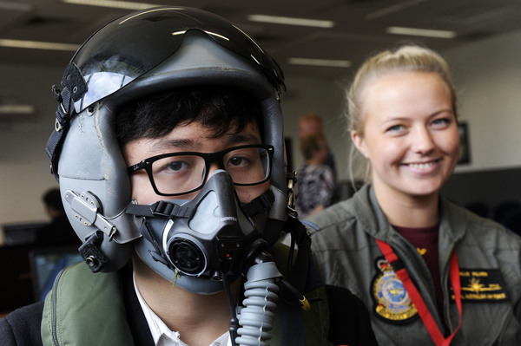](https://berwicknews.starcommunity.com.au/files/2019/03/simulator_191403_03-1.jpg)Year 10 student Ratanak Kem with RAFF pilot officer Isabella Filmer. 191403_03. Picture: STEWART CHAMBERS

By Brendan Rees

Students at Nossal High School in Berwick have swapped their books to take control of a multi-million dollar fighter jet.

The Royal Australian Air Force brought its F/A-18F Super Hornet simulator for 33 students from four year levels to try out which aimed to develop interest amongst young people in aviation careers.

The experience included a flying lesson with an instructor, air traffic control games, and an aircrew life support gear demonstration.

Year 10 student Eunice said “It gave me insight as to what it means to be a pilot and opened up possible career paths.”