Making her mark in politics
01/04/2019
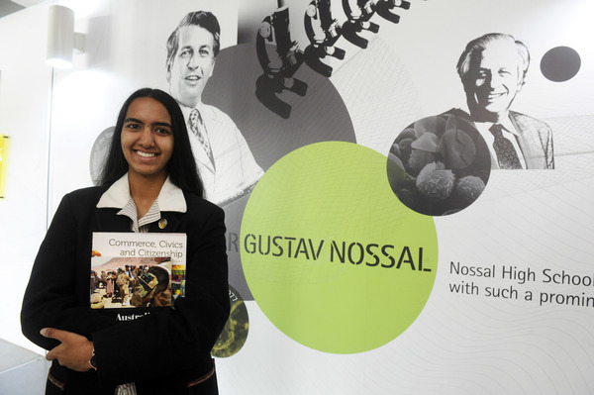
Nossal High School student Shalaaka Brahmavar has been inspired to bring about change to the Australian Constitution after attending a summit in Canberra. 191420_05. Picture: STEWART CHAMBERS
By Brendan Rees

Shalaaka Brahmavar from Berwick’s Nossal High School has spoken about her amazing experience after attending a national summit in Canberra.
Shalaaka attended the 24 the National Schools Constitutional Convention held at the Museum of Australian Democracy at Old Parliament House in Canberra from 19-21 March.
“It really highlighted the importance of democracy and how vital the involvement of the public is to shape the future,” she said.
“Being able to meet and question several important politicians, including the Speaker of the House, Tony Smith, and Deputy President of the Senate, Sue Lines, was an amazing opportunity that I never would have had otherwise.”
Shalaaka joined about 120 senior student delegates who debated the topic: ‘A new constitutional preamble for Australia?’
A variety of constitutional experts were on hand including Professor Kim Rubenstein from the ANU College of Law who discussed the context and background of a preamble.
Shalaaka said it gave her the opportunity to meet like-minded students from all across the country.
“The entire atmosphere of the event was quite formal and took place in some of the most important locations for Australian democracy, including the New and Old Parliament Houses as well as the High Court,” she said.
“I’m immensely grateful for this opportunity and after spending time with so many amazing students, I think it’s safe to say that the future of the country is in great hands.”
Student groups prepared draft preambles which were voted on in a mock referendum conducted by the Australian Electoral Commission.

