LEADER

Melbourne school captains on how they can shape our future
Leader
March 26, 2019 12:47pm
They are often accused of being the generation of me, but Melbourne’s Year 12 school captains are doing their bit to dispel the myth of selfish Generation Z.
In one of the most comprehensive school projects ever attempted, Leader Community News asked more than 160 captains from all over Melbourne: What difference can your generation make to the world?
The results are published in the Leader papers delivered across Melbourne this week. In them, the students write in their own words what they and their peers hope to achieve when they are in positions of power.
“We have the drive to resolve shared challenges and the power to leave the world in a better state than when we came into it,” writes Toorak College’s Mietta Symmons-Joyce (17).
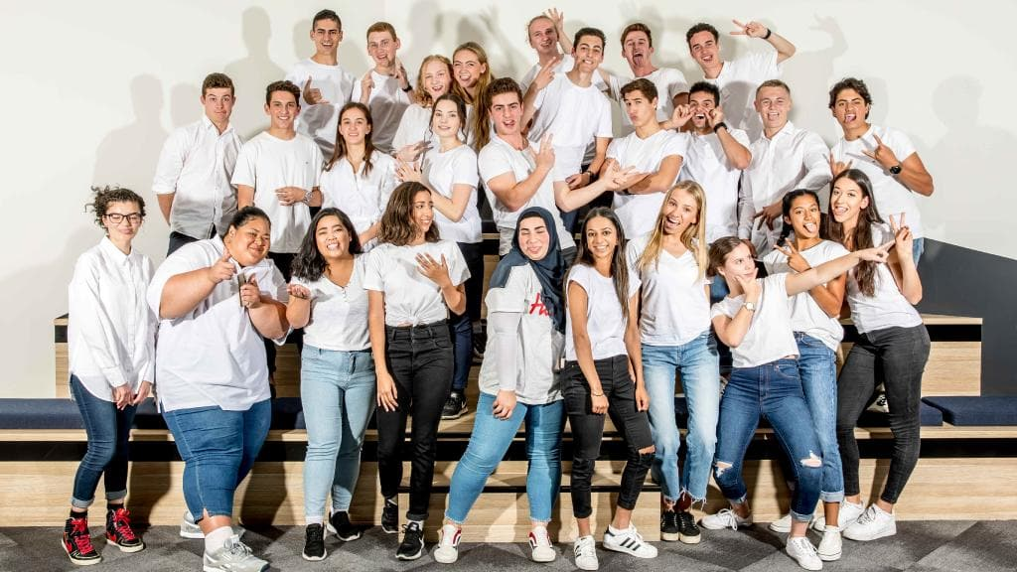Captains from 26 different schools at the Leader office for our photo shoot. Picture: Tim Carrafa
Students share their concern for the environment, hopes of using technology for good, the need to embrace change and the belief that any change comes through their actions.
They also take their responsibility to lead by example very seriously.
“I believe that we are without a doubt the passionate, creative and audacious next generation the world needs to take on unprecedented challenges and opportunities,” writes Tom Yakubowski, 17, from Box Hill High School.
To capture the fantastic picture above, we invited captains from 26 schools across Melbourne to the city.
It was an uplifting experience, as we watched how they all interacted.
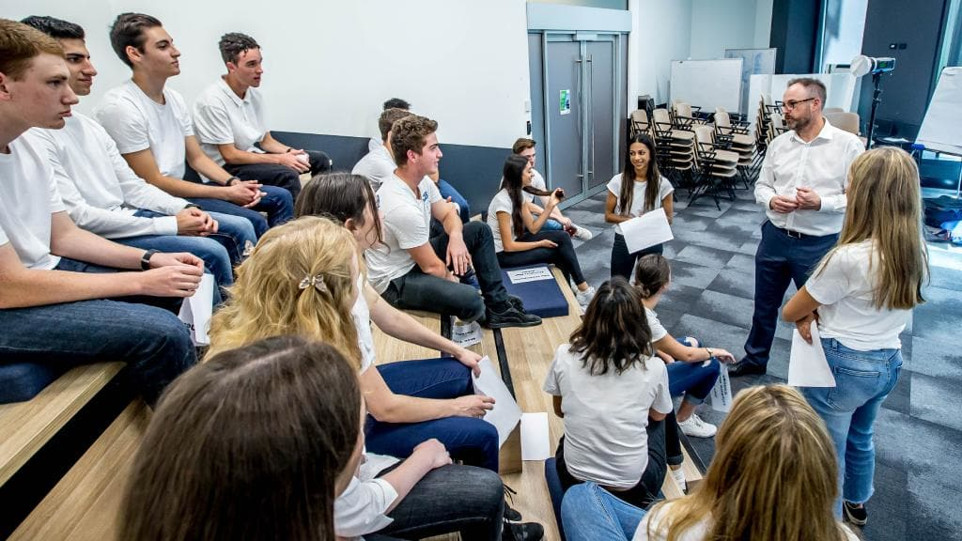Leader editor in chief Andrew Rennie talks with some of the school captains. Picture: Tim Carrafa
Just minutes after meeting for the first time they were chatting like they had known each other all their lives, comparing war stories.
And when quizzed as a group on issues such as mental health or social media bullying, they were measured and thoughtful in their answers.
They all showed a maturity well beyond their years.

Cranbourne 2019 school captains share hopes, dreams for future
They’re the next generation of leaders, but what do Melbourne’s school captains really have to offer the community?
In one of the most ambitious projects ever undertaken by Leader Community News, we asked every Year 12 school captain in Melbourne: What difference can your generation make to the world?
The words below are their own and the responses — like the students themselves — are insightful.
They show hope, optimism and a real desire to make a difference, undaunted by the challenges ahead.
And they all show a maturity well beyond their years. Our future is in very good hands.

BEACONHILLS COLLEGE
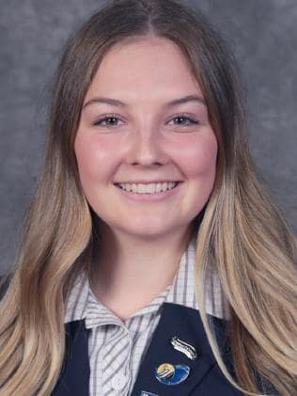
Phoebe Hird, 18
Phoebe Hird.
Change starts with one person. To some it can seem too overwhelming or seem too impossible for one single person to make a difference, but all it takes is one person with one goal. As I aspire to study Environmental Science and Conservation after school, my motivation has always been to ‘save the planet’. While seemingly impossible for one person, beginning with the little things like picking up rubbish at the beach create a ripple effect much bigger than you could ever hope for. If we each set our own ‘seemingly impossible’ goal we can inspire and lift up others, creating the difference we want to see in the world.
Ethan Christian, 17
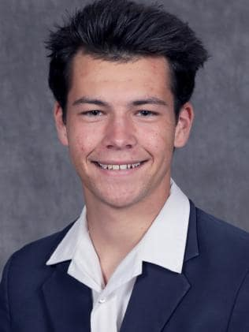
Ethan Christian.
The difference that our generation can have on the future, is immeasurable. There are no limits on what we as individuals and a wider community can achieve with the help of one another.
Our generation is healthily equipped with innovative, and hungry young minds who have a genuine desire to have a lasting and profound effect on the world, and the people within it.
We have creative and inspiring minds aplenty, and just as equally, we have dedicated and loyal followers who are willing to sacrifice whatever needs are, in order to show their backing for the cause.

BERWICK GRAMMAR SCHOOL
Darcy Dillon, 18
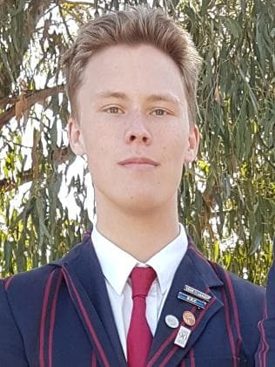
Darcy Dillon.
When asking my generation, a more appropriate question would be, ‘what differences can’t your generation make to the world?’
You see, the generation that I have grown up in and now feel a part of, is so extremely diverse and culturally-aware, that I believe that there is no limit to what changes we can make, together.
There are many pressing issues still extremely relevant to humans all over the globe, such as racism and religious/belief-discrimination; and with the open-minded generation that we have, I strongly see us making a change to that for the better.
Matthew Kent, 17
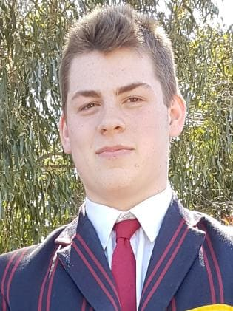
Matthew Kent.
This is undoubtedly a tough question. Put simply, the answer is I don’t know. Looking back in history, and all that we have achieved now, I don’t think my grandparents or my parents could have predicted the massive change that the world has gone under so far and I don’t think that I can say with any accuracy how my generation can change the world. But looking at the strides we’ve made in human rights and environmental efforts so far, I believe that my generation and I have a lot of positives to bring to the world that will soon be ours.

HALLAM SENIOR COLLEGE
Paige Formaran, 17 and Georgia Kristalyn, 17
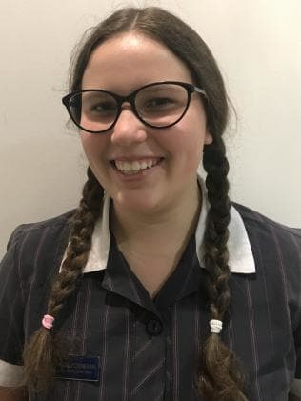
Paige Formaran.Georgia Kristalyn.
We feel as though our generation can make a difference in the world due to our awareness and understanding of different cultures, sexuality (LGBTQIA+) and genders.
Understanding these topics makes the world a more peaceful and compassionate place for everyone. gay or straight, male or female. These are the two choices that past generations were given about their sexuality and gender preference as opposed to the eclectic spectrum with a funky acronym our generation have promoted today. The LGBTQIA+ community are growing stronger and being internationally recognised for their struggles and efforts.
Although, some may see our growing understanding of a larger spectrum as “ridiculous” and “unnecessary”. Allowing people to specify their own identification explicitly is promoting self confidence and self love, making the world we live in today a more accepting one. Sensitivity to the subject is making people aware of problems that we haven’t discussed before. Acceptance of differences is bonding us together even more. Finally, encouraging every soul to express their true nature, culture and personality is our generation painting glorious technicolour over a black and white world.

HAMPTON PARK SECONDARY COLLEGE
Cain Stansfield, 17 and Jessica Hogan, 17
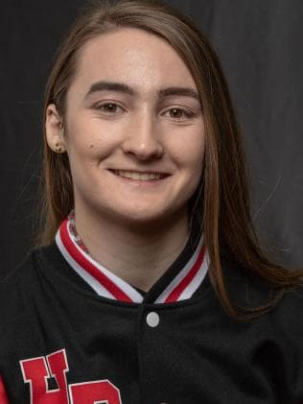
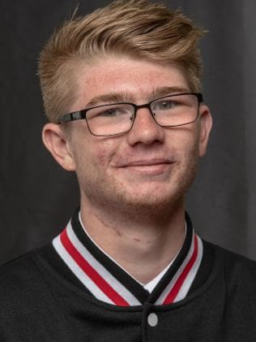
Cain Stansfield.Jessica Hogan.
As young leaders, we appreciate the experiences and opportunities provided by past generations and we acknowledge how these have shaped who we have become.
We are proud to have the opportunity to inspire other students to proactively contribute to the wider community and build a strong sense of pride and belonging.
We challenge each other to value the importance of education and see ourselves as lifelong learners. This includes engaging deeply in world events, understanding and valuing the diversity in culture and experiences within the community. It is through this knowledge that we are better prepared to engage as ethical and responsible citizens and having the courage to uncover inequity.
We urge ourselves to be open-minded and explore different perspectives in key world events. We are forward thinking and innovative in our actions and we are unflinching in the face of future obstacles, demonstrating high expectations of ourselves and others.
As a team, we believe it is our moral purpose to call out injustices and in doing so, encourage our peers to strive for their own distinction. It is through this awareness that we can play our part in making a difference in the world.

HERITAGE COLLEGE
Tibesso Witago, 17 and Alana Saluni, 17
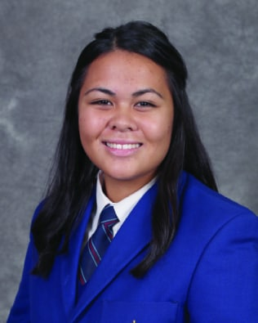
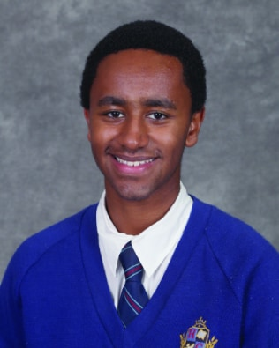
Tibesso Witago.Alana Saluni.
There’s a Latin proverb that states: ”times change and we change with them”.
Life just couldn’t be any quicker. A moment ago we began high school, and here we are, in our last year of school. Generation Z as we are known, born at the foundation of the 21st century, has seen the rapid development of technology, unlocking key information into many cancers, allergies and vitamin deficiencies.
Surely the generations to come will do even more incredible things that will leave many people astounded, even the very wisest of our generation. Just like the Latin proverb, we can review the past through the lens of history, and our today will soon enough become tomorrow's history lesson.
Did the first man know that humans need a roof above their heads to sleep? Did Benjamin Franklin know his research into electricity would be a shining light to paving the way for Thomas Edison to develop the renowned light bulb?
It’s too hard to call what our generation might be able to achieve, but we are sure that whatever one individual does, it can inspire another to something far greater.

HILLCREST CHRISTIAN COLLEGE
Deaghlan Deaville, 17
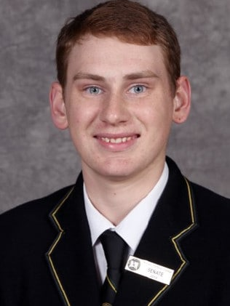
Deaghlan Deaville.
My vision extends beyond school. Not only do I want to see students excel in the areas they are gifted and interested in, but as a school, to get students involved in giving back to our community.
Hillcrest Christian College builds on four pillars, namely: Faith, Character, Learning and Service. Students are encouraged to develop in these areas, to not only learn at school, but also get to know the heart of God. I want to encourage students to embrace and act upon what they learn, and become the people who positively change the world.
Emily Ward, 17
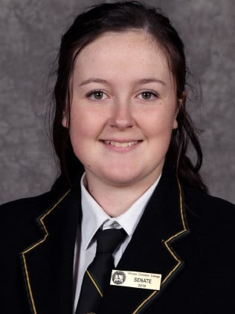
Emily Ward.
Our generation not only has the knowledge of new technologies and insights into the modern world but, also has the backing of parents, teachers and mentors that can help guide us by using their past experiences.
With the joint information of the old and new, our generation is fully equipped with the intel to make a positive difference on the world today. The world is ever changing and our peers and friends have the ability to mould it into something we wish to see flourish and grow into the world we want to work, play and live in.

LIGHTHOUSE CHRISTIAN COLLEGE
Ranushi Poobalasingam, 17
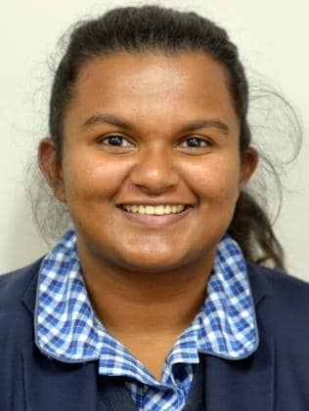
Ranushi Poobalasingam.
I believe our generation can change the culture of discrimination that we live in right now. We are capable of breaking down the negative barriers that has been put in place by society, and can remove the issue of discrimination all together. I believe by working on our communication with each other and by realising that everyone is the same regardless of their features, our generation can get rid of the destructive culture of discrimination that is influential to our world.
Nathaniel Stephens, 17
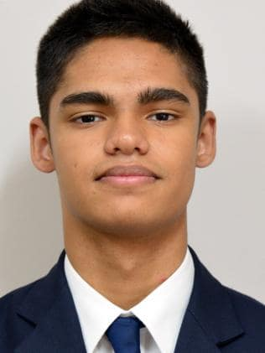
Nathaniel Stephens.
I believe that I’m part of an empathetic and efficient generation. We understand each other on a deeper level, and are able to offer advice to our peers during challenging times. As a generation, I also truly think that we’ll be able to find quicker ways of doing tasks, so as to consume less time and energy.
Some people see the world in a state of decline, but I reckon we’ll be able to think outside the box and find loopholes that fix many global issues. Most people talk about change, but I believe my generation will be that change.

NOSSAL HIGH SCHOOL
Aleena Bino, 17
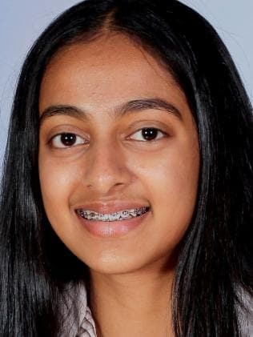
Aleena Bino.
As I reflect upon my past schooling years, I realise just how grateful I am for my education.
Our world is desperately in need of more people who are loving to everyone regardless of personal characteristics and more people who care for the environment and its wildlife. By striving to do this in my own life, I hope to inspire others to do the same.
The issues our society faces today including poverty, climate change, war and abuse can all be ended if we all share more love, and this is what my vision for the future is.

Alvin Santhosh, 18
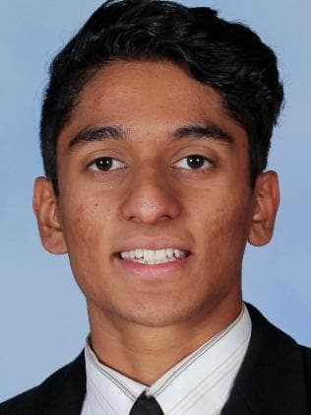
Alvin Santhosh.
Leadership is the capacity to translate vision into reality.
Leadership is not just about leading but is the enabling of my peers to become leaders in their own right. We wish to achieve this through portraying ourselves as active role models, displaying the wisdom and courage that all leaders should strive for. We will showcase that you can be the driving force of change.
Now more than ever, the world needs leaders willing to fight for what is right, and we believe we can help make that a reality.

ST PETER’S COLLEGE CLYDE NORTH CAMPUS
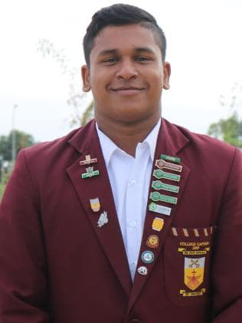
Kartik Pillai, 17 and Maureen Gabriel, 17
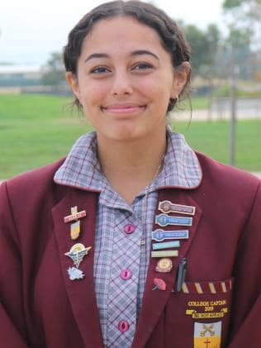
Maureen Gabriel.Kartik Pillai.
“What difference can your generation make to the world” – such a profound question, yet we give it a simple answer – defiance. Defiance is usually followed with negative verbs: defiance to comply, defiance to participate, defiance to co-operate. Generally, we can agree, it carries a negative connotation. Our generation will give defiance a new tone.
Currently our world is rapidly changing, consumerism and perhaps materialism is a phenomenon that is taking control of the 21st century. More often than not, consumerism and materialistic desires dictate our current society. Those who profit off that desire, are brilliantly skilled in their ability to convince us that we need the latest gadgets, clothes, phones etc. However, our generation will refuse to accept this. We will be the generation of producers rather than consumers; producers for those who are less fortunate than we are, producers of love and tolerance, producers of hope for a sustainable future. We will not allow consumerism to consume us.
We’re the generation that refuses to be victims of the decisions made by our current leaders, instead we will learn from them, we will improve and we will make a difference.
In defiance we will, as the bible mentions 365 times - “Be Not Afraid”.

ST PETER’S COLLEGE CRANBOURNE CAMPUS
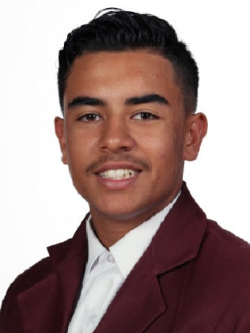
Jonathan D'Rozario, 18 and Elizabeth Lupeamanu, 17
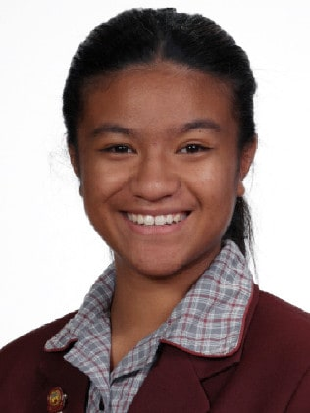
Jonathan D’Rozario.Elizabeth Lupeamanu.
This is a very difficult question to answer, because there is so much that could be changed, and changed for the better, not only for us but for other generations.
Our generation will make a real difference, to the health and wellbeing of our community. We will step up and set an example and enact real change in key health issues, particularly obesity, which we believe is associated with reduced sports participation and daily sugar intake. Governments need to act with sugar lowering consumption policies. In regards to sports participation we need to see more support by Government for sports in schools.
Both Jonathon and I have a strong belief that change will come through our actions, “every change starts with self”.
Change is just a mindset, and we have been brought up to believe that we all can make a difference. Faith is the basis of making any change.
We need to look out for those less fortunate. Every person has different strengths in life and we will use and encourage these strengths for the whole community. We will become a more accepting of people’s differences – multiculturalism at its best.
We believe this generation are confident and courageous individuals, who can suggest, make and demand change.

